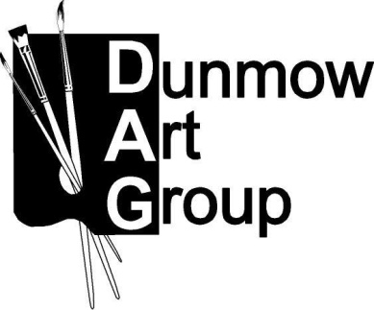DUNMOW ART GROUP CONSTITUTION

1. NAME The Group shall be known as the Dunmow Art Group (DAG).
2. AIM To further members’ practice and enjoyment of Fine Art by:
- drawing and painting together
- arranging appraisals (criticisms), discussions, lectures, demonstrations and visits
- arranging exhibitions of work
3. MEMBERSHIP Membership shall be open to all persons interested in Fine Art, but may be limited in number by the Executive Committee having regard to the activities of the group and the facilities available to it. All applications for membership shall be subject to approval by the Executive Committee.
4. MEMBER Member Emeritus may be awarded at the discretion of the Executive Committee to EMERITUS members of long-standing who are no longer able to participate fully in the Group’s activities, but who wish to retain an association with the Group. They shall pay no subscription and shall enjoy all the benefits of membership.
5. CONCESSIONS Concession status will be awarded to members over the age of 90. They shall pay
no membership subscription, but shall be required to pay entry fees to exhibitions and attendance fees for meetings as appropriate.

6. MANAGEMENT The affairs of the Group shall be managed by an Executive Committee. Consisting at a minimum of an organiser and a Treasurer. They shall be elected annually at the AGM. They may be re-elected. The Executive Committee shall have the power to co-opt. Should no-one be willing to take on these roles, the Group in its current format should be dissolved.
7. EXHIBITIONS An Annual Exhibition shall be held, the Exhibition Officer will have complete authority of the format of the exhibition and hanging of artworks with input from the Group Committee.
8. MEETINGS & These shall be held in accordance with the annual programme arranged by the
ACTIVITIES Executive Committee.

9. GENERAL The Annual General Meeting shall be held each year to elect Officers and
MEETINGS Committee members and to hear a report on the year’s activities and financial accounts. The Executive Committee may call an Extraordinary General Meeting or do so at the written request of not fewer than ten members.

10. SUBSCRIPTIONS Subscriptions necessary for the organisation and activities of the Group shall be paid to the Treasurer at the AGM.
11. PRIVACY NOTICE Data Protection privacy notice: Your personal data will only be used to circulate DAG information, news and activities within the group, the list is for group use only and will not be available to anyone outside the group. The full policy is available on request.
12. FINANCE An account shall be maintained on behalf of the Group at a bank agreed by the Executive Committee 3 signatories shall be nominated by the Executive Committee. They must not be related nor members of the same household. All payments will be signed by 2 signatories (for BACS payments and other non-cheque items a requisition note will be signed by 2 signatories and held by the Treasurer). Records of income and expenditure will be maintained by the Treasurer and a finance statement made at each Executive Committee meeting.
13. CLOSURE Dissolution of the Group should take place if circumstances in item 5 of the constitution occur or a simple majority of members agree at an AGM or EGM on the dissolution of the Group. If it is agreed to dissolve the Group, any remaining monies and all other assets, once outstanding debts have been paid, will be donated to a local charity or non-profit organisation as agreed at the meeting to dissolve the Group.
14. ALTERATIONS Alterations to the Constitution shall be made only at a General Meeting; any proposals to be made 28 days beforehand.

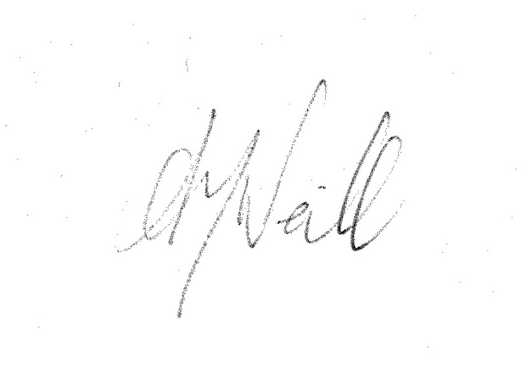
Audrey McNeill
Chair

